Automation Framework User Guide

# Getting the Automation Framework

In order to run automated tests the Automation Framework code has to be downloaded and built, this is done through Visual Studio 2015 and requires a connection to the ‘Engineering Git Server’ configured.

To get the latest code perform the following:

1. Select ‘Team Explorer’ tab within Visual Studio 2015.
2. Select the ‘Branches’ option.

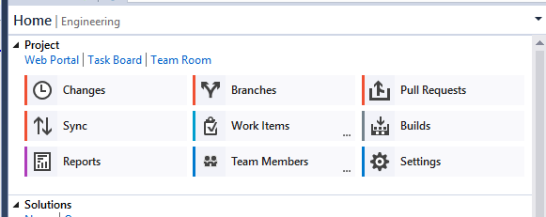

1. Expand ‘remotes/origin’, locate branch ‘Feature_VfpTestAutomation’ and select ‘Checkout’.

This should download the code to your working folder.

1. Select the ‘Home’ icon from the ‘Team Explorer’ menu.



1. In the Solutions list select ‘VPCRegression.sln’, if it doesn’t appear in the list click the ‘here’ link at the bottom which will open a Windows Explorer window to your working folder, from here double click ‘QA_Automation\vNext\VPCRegression.sln’.

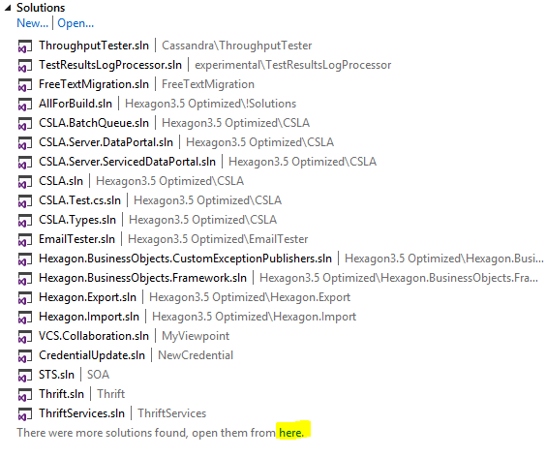

1. The solution should open as below. Right click the Solution at the top level and select ‘Build’ and ensure it builds successfully.

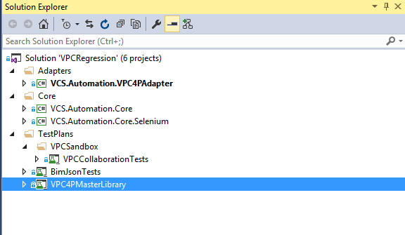

# Test Automation Framework Config Utility

The Test Automation Framework Config Utility PowerShell application is used to manage the various Environments that the Automation Framework is executed on. The Config Utility should be installed before attempting to execute any tests.

## Installing the utility

To install the Config Utility:

1. Open PowerShell command prompt.
2. Type the following:

‘Set-ExecutionPolicy –Scope CurrentUser RemoteSigned’ and hit ‘Enter’

If you don’t have local admin rights this step will error, please contact system administrator to enable before continuing.

1. Enter ‘Y’

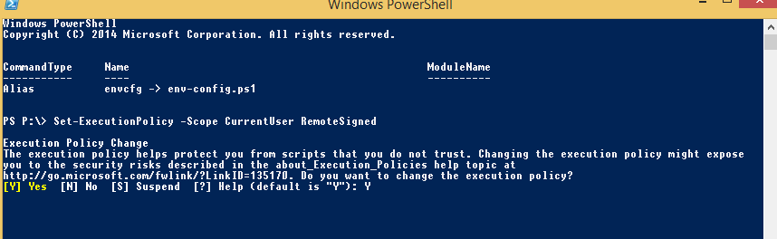

1. Type the follow:

‘New-Item –path $profile –type file –force’ and hit ‘Enter’.

1. Open a Windows Explorer window and browse to the following directory opening the following file in notepad

‘C:\User*your.username*\Documents\WindowsPowerShell\Microsoft.PowerShell_profile.ps1’.

1. Add the following line
2. ‘New-Item alias:envcfg –value C:*GitWorkingDirectory*\QA_Automation\vNext\TestPlans\VPC4PMasterLibrary\SolutionItems\env-config.ps1’

Save and close the file.

1. Open PowerShell command window and type ‘envcfg’ and hit ‘Enter’. The Config Utility should open as below.

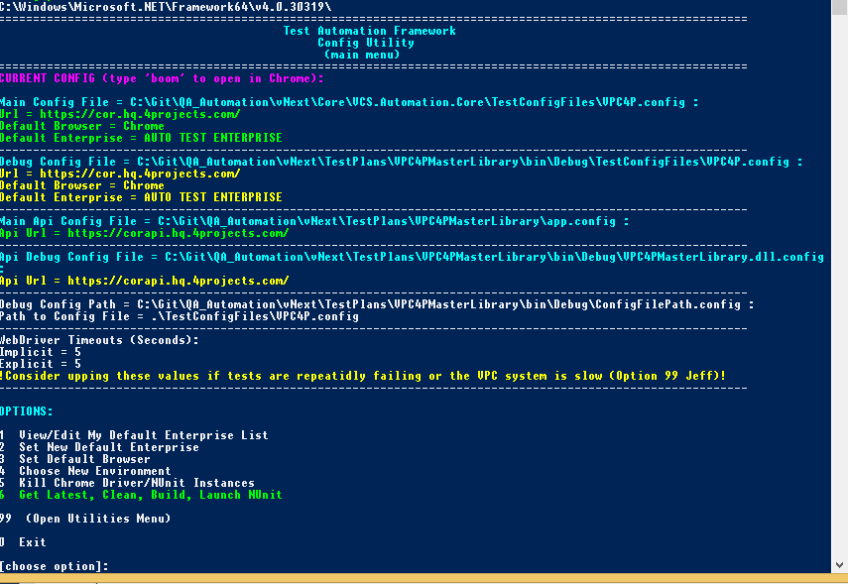

## Using the Config Utility

The Config Utility is a menu driven application which allows you to set numerous options within the Automation Framework without having to use Visual Studio. There are a number of features available within the Config Utility, however this document is only going to cover the two main ones, ‘Set Default Browser’ and ‘Choose New Environment’.

### 3. Set Default Browser

Depending on which Browser you want to use for executing your automated tests you can set the option by entering ‘3’ from the menu which will open a list of options.

Current supported Browsers are Chrome, FireFox and IE.

Enter the required option number and hit ‘Enter’.

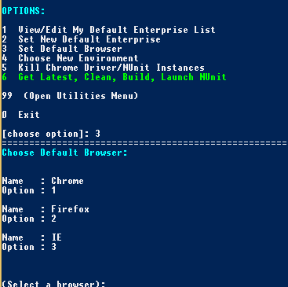

### 4. Choose New Environment

To select the required environment to execute tests select option 4, this will list all the available environment options grouped by geographical location (UK, US, AUS). Enter the required option and hit ‘Enter’ and then follow the on screen steps to close.

This will have updated all the necessary config files within the solution.

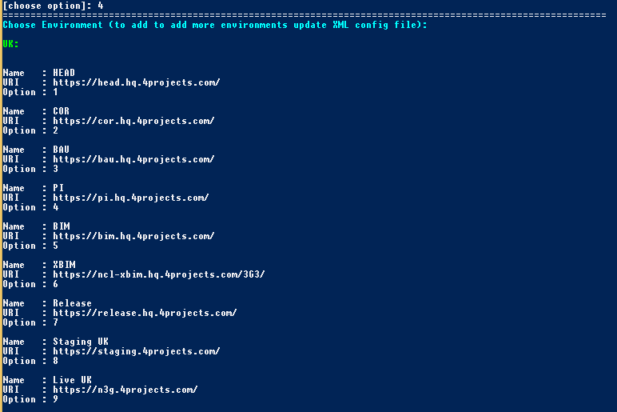

# Identifying Available Tests

Tests have been created and structured to reflect the current structure in MTM, which is, they are grouped into functional areas. In order to access them from within Visual Studio you need to enable the Test Explorer Window and build the solution;

1. Open Visual Studio 2015 and from the menu select the following ‘Test>Windows>Test Explorer’



1. Open the ‘VPCRegression’ solution by selecting it from the Recent solutions list, if its not available there use the ‘File>Open Solution’ option and browse to it in your mapped directory.

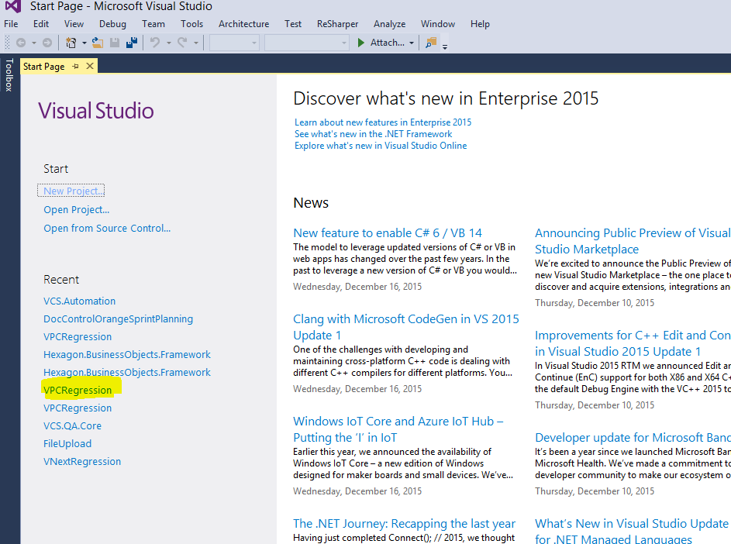

1. Once the Solution is open, right click and select ‘Build Solution’. Once built the tests will be available within the ‘Test Explorer’ tab. In order to get the Test Area Grouping, right click in the Test Explorer window and select ‘Group By>Class’

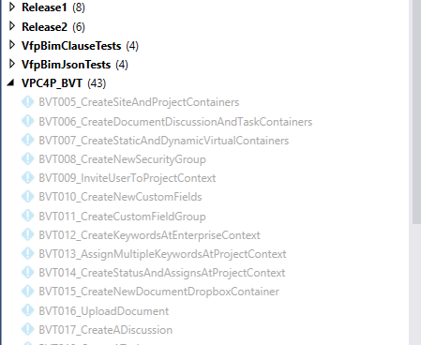

# Executing the tests

Executing the tests is as simple as highlighting the required tests to run, right clicking and selecting ‘Run Selected Tests’. The tests are completely atomic (with the exception of the BVT and BVT Enterprise User tests) so can be ran in any order. The BVT requires the BVT Enterprise Users tests to be executed first and the BVT has to be executed in the order in which they are labelled.

Once ran the test will either pass or fail, any failed tests should be re-ran. There are often fails for many reasons (typically due to a new build deployment) however a second run of the test tends to fix most. Should a fail occur again, run the test manually and report the issue to an engineer.

Once ran, update in MTM accordingly.

